- Voorburg Group Newsletter  February 2023  Newsletter Mindset:  - Writing concise contributions is key, because inboxes are a highly competitive space, often crowded.  - Useful and user-friendly.  - Use it as a platform to establish collaborative exchanges. Do not hesitate to reach out to those doing similar things.  Newsletter Content:  - Welcome  - Contribution from Mexico new Survey on International Trade Services.  - Contribution from the United States article about Automotive dealership.  - Announcement of the Voorburg Group on Yammer Global Network.  - OECD Informal Expert Group on Trade in Services Compilation and Asymmetries.  - Announcements. | Newsletter Issue N°1  Welcome to the first issue of the Voorburg Group Newsletter:  The Voorburg Group on Services Statistics, whose name comes from the city in the Netherlands where the first meeting occurred 36 years ago, is excited to launch its first newsletter! Ever since that first meeting, member countries and participants from all over the world have shared working papers and presentations, which have helped us build cooperative knowledge-based exchanges and the development of standards to assist us in our measurement challenges in the Service Sector.  This newsletter constitutes a beautiful opportunity to strengthen the links between the member countries and participants. It is a symbolic bridge to bond us, as an expert community whose compound knowledge can help us all improve the prevailing practices, in our continued effort to improve our indices.  We have one purpose which is mainly to increase interactions and build bridges between members to increase cooperative work and points of interaction during the year. Not limited to the once-a-year meeting, this is our outlet to hear and be heard. We’d love to have your contribution next!  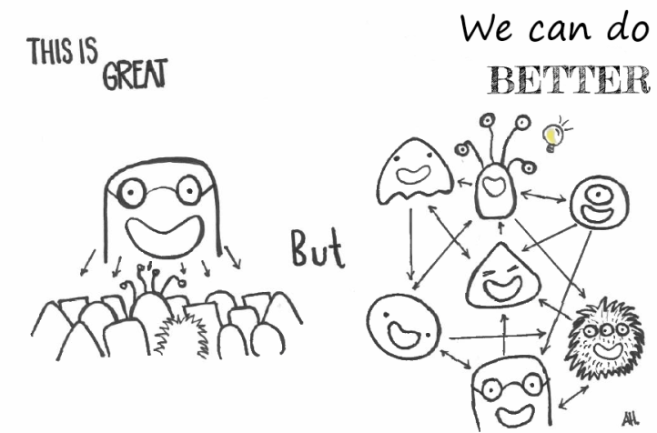

Contribution from Mexico new Survey on International Trade Services.  INEGI  Contact:  Ariel Juarez Morales:  ariel.juarez@inegi.org.mx  Luis Centeno Martinez:  luis.centeno@inegi.org.mx  Read the full article following this link: https://www.inegi.org.mx/investigacion/ecis/2021/  OR  Watch the YouTube Webinar on Measurement of International Trade in Services: Relevance and Experiences which took place on November 29, 2022, and was hosted by INEGI with the participation of the World Trade Organization (WTO), the United Nations Conference on Trade and Development (UNCTAD), the Organization for Economic Cooperation and Development (OECD), the United Nations Statistics Division (UNSD), the Bank of Portugal and the U.S. Bureau of Economic Analysis (BEA).  Use the following link: https://www.youtube.com/watch?v=9mVIcqOD0Dk | Experimental Statistics: Survey on International Trade Services (ECIS) Mexico.  Our colleagues at the Department of Economic Statistics and Geology INEGI in Mexico have launched a new survey, hooray! We all know how much work goes into preparing and launching new projects.  Great news is that it is online and available for other countries interested in this development. They have classified it as experimental statistics since it is an ongoing project and the base years have been a Pandemic period.  Goal: To produce primary statistical data on enterprises that carry out services transactions abroad. On the one hand, this will establish a base to measure international trade in services. On the other hand, it will allow the development of robust macroeconomic calculations, while it will later support the design, implementation, and evaluation of public policies on this matter.  International Trade in Services (ITS) are considered here in the conventional sense, as export and import transactions between residents and non-residents. This area has increasing importance for the Mexican economy which becomes apparent as we observe the results. In addition, ITS also covers the services supplied through locally established enterprises that are controlled by foreign capital. Another area of importance is the measurement of income flows and expenses abroad, highlighting the collection of information from the commercial partners with whom the services are carried out and the mode of supply through which they are carried out.  Automotive dealerships 2007–19: profit-margin compression and product innovation. In the United States.  Contribution from the United States article about Automotive dealerships.  BLS  Contact:  Melanie Santiago, BLS  Santiago.Melanie@bls.gov  Read full article following this link: https://www.bls.gov/opub/mlr/2022/article/automotive-dealerships.htm  Read full article following this link: https://www.bls.gov/opub/mlr/2022/article/automotive-dealerships.htm  In October 2022, the U.S. Bureau of Labor Statistics published 12 years of analysis of Automotive dealerships, the variations in profit margins, and the changes the industry has implemented to adapt to a changing market.  Vehicle dealerships are the primary intermediary between consumers and manufacturers in the new-vehicle supply chain, making them integral to the U.S. economy.  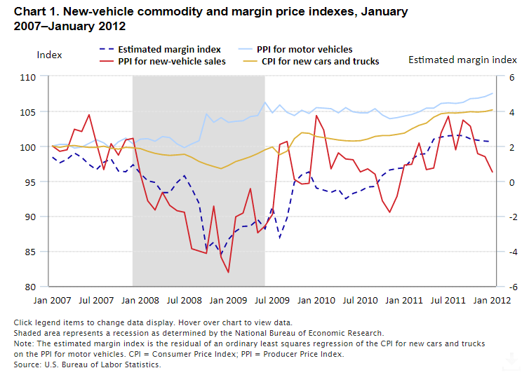 https://www.bls.gov/opub/mlr/2022/article/automotive-dealerships.htm  "From the 2007–09 Great Recession to the onset of the coronavirus disease 2019 pandemic, the new-vehicle market in the United States changed significantly. Consumer and producer price trends examined in this article show how dealers’ profits on new vehicles declined and, subsequently, how dealers successfully expanded financial services to improve revenue and profit.”
Voorburg Group on Yammer  Follow this link to join the  Voorburg  Group on Yammer:  https://www.yammer.com/unstats/#/home | Announcement of the Voorburg Group on Yammer Global Network.  Follow this link to join the Voorburg Group on Yammer:  https://www.yammer.com/unstats/#/home  As mentioned at the beginning, we want to use the newsletter to build bridges and strengthen the relationship between Voorburg Group members. The newsletter is the medium through which you hear news from the Voorburg Group. But we want to spread more than just news. We want reactions, questions, information from the readers of the newsletter.  To facilitate this, we have decided not only to distribute the newsletter by email, but also to use the Global Network of the UN Statistics Division. The platform works like a social network (e.g. Facebook, LinkedIn, ...) and is aimed at statisticians and data officers.  Some of the thematic groups on this platform are open to everyone, others are restricted to a specific group of people. The Voorburg Group on Yammer initially starts as a private group, i.e. only people on the mailing list of the Voorburg Group can join this group. Please register and join our group! (The email with which you received this newsletter also has the registration instructions attached)  Please use this forum to get in touch with us and other users. Share information with us about new developments in service statistics in your country. Ask questions about the Voorburg Group and topics you are currently working on. Tell us about topics you think we should cover in the next newsletter. Ask questions about the content of the newsletter. Any and all feedback is welcome.
OECD Informal Expert Group on Trade in Services Compilation and Asymmetries.  If you would like to join us, hear more about the Asymmetries Group, or feel your work links up with ours please contact:  WPTGS@oecd.org | 5. OECD Informal Expert Group on Trade in Services Compilation and Asymmetries.  At the last Voorburg Group meeting, the United Kingdom Office for National Statistics (ONS) introduced the OECD Informal Expert Group on Trade in Services Complication and Asymmetries. The Group supports international collaboration, focusing on identifying causes of asymmetries and sharing understanding to help improve data quality and reduce asymmetries.  The Asymmetries Group has met twice so far. We have discussed various compilation issues and agreed priority topics to focus on. A Task Team on Geographic Allocation has been established and work is currently being scoped out.  The next Asymmetries Group meeting took place, virtually, on 21 February, 14:30-16:30 CET.
54th Session of the United Nations Statistical Commission  Follow this link for more information:  https://unstats.un.org/UNSDWebsite/statcom/54 | Announcements  1. 54th Session of the United Nations Statistical Commission  The Statistical Commission consists of 24 member countries of the United Nations, elected by the United Nations Economic and Social Council on the basis of an equitable geographical distribution. The term of office of members is four years.  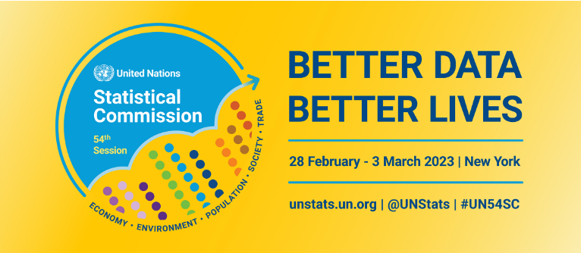  The Side events calendar provides an overview of virtual side events on the Road to the Commission and in-person side events during Commission week, including concept notes and registration details for open events.  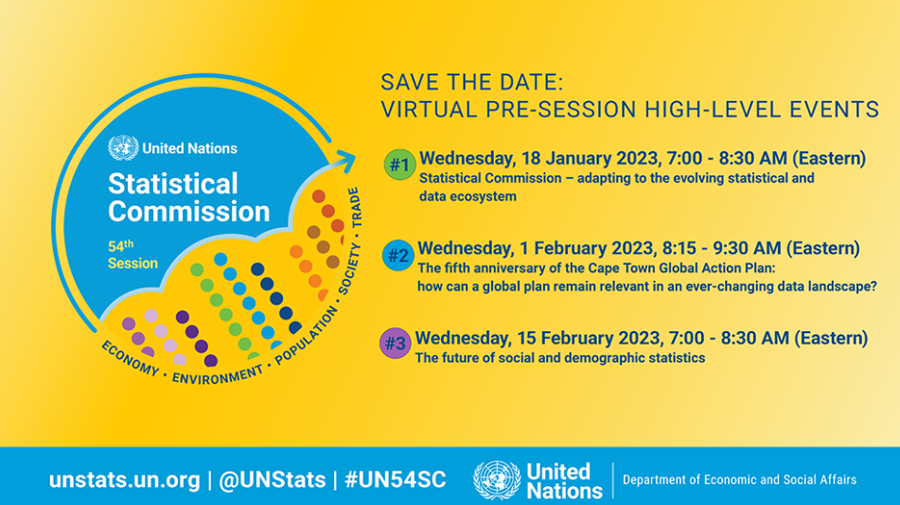
Contact Us  Organization Name  Voorburg Group  For issues related to the Newsletter  Emails:  Dorothee.Blang@destatis.de  RIIKKA-MARIA.KORHONEN@ons.gov.uk  angela.hernandezsantacoloma@bfs.admin.ch  For issues related to the Voorburg Group in general  Marcus Friden  Marcus.Friden@scb.se  OR  Bonnie Murphy  Murphy.Bonnie@bls.gov  Website  https://voorburggroup.org | 2. Is your country ready to host? We are looking for the 2024 host country.  Contact: Bonnie Murphy or Marcus Friden.  “Coming together is a beginning,  Keeping together is progress,  Working together is success.”  Henry Ford  - We are happy to share your contributions, feel free to e-mail the Newsletter group if you have some topic to feature, a paper, results of a study, a question to ask, a group you want to build.  Get in touch with Riikka, Dorothee or Angela.  Author: Angela Hernandez Santacoloma.  Co-edited: Dorothee Blang & Riikka Maria Korhonen.  Yammer contribution: Dorothee Blang.

